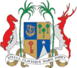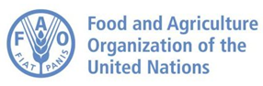

GCF/FAO Project, ‘Advancing the agriculture, water and energy pipeline, with increased awareness of key stakeholders and strengthening capacities of the National Designated Authorities (NDA) and direct access applicants in the Republic of Mauritius’
Validation Workshop for Energy Sector (Deliverable 2.2.7.1)
Provisional Agenda
Date: 23 July 2026
Time: 09.30 to 15.00hrs
Venue: Hennessy Park Hotel, Ebene
Time | Agenda item | Responsible
8:30 – 9:30 | Registration of participants – Networking | FAO
9:30– 9:45 | Welcome address and Context setting | FAO/Consultants
9:45 -10:45 | Presentation of findings of feasibility study /CBA | International/National Consultant
10:30-10:45 | Tea / Coffee Break | All
10:45-11:00 | Questions & Answers Session -Feasibility study & CBA | International/National Consultant
11:00 – 12:00 | Proposals and feedback on innovative solutions to enhance RE energy adoption pathways | Consultants and participants
12:00 -12:30 | Proposals on capacity building needs for enhanced enabling environment | Consultants and participants
12:30- 13:30 | Lunch Break | All
13:30 – 14:30 | Briefing session & Feedback | All
14:30-15:00 | Vote of thanks | FAO

